Insert at end of Doubly Linked List
Problem Statement: Given a doubly linked list, and a value ‘k’, insert a node having value ‘k’ at the end of the doubly linked list.
Examples

Example 1:

Input Format:

DLL: 1 <-> 2 <-> 3 <-> 4

Value to be Inserted: 6

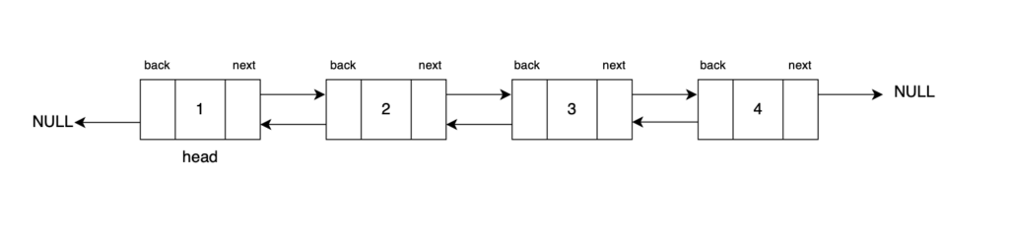
Result: DLL: 1 <-> 2 <-> 3 <-> 4 <-> 6

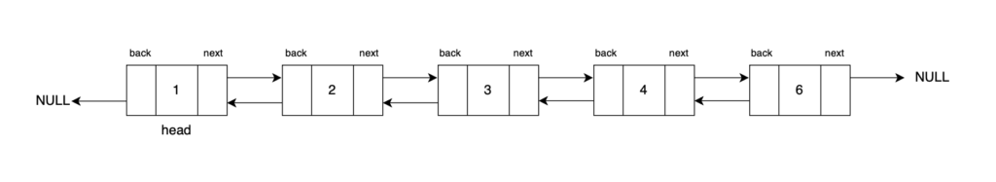
Explanation: A new node with value 6 has been inserted at the end of the doubly linked list after the tail node.
Approach:
To insert before a given node, begin by identifying its previous node. This step is assured since the provided node is never the head. Create a new node with the specified value and set its back and next pointers to the previous node and the given node, respectively. To seamlessly integrate the new node into the doubly linked list, set the previous node's next pointer and the given node's back pointer to the new node.
Step 1: Traverse through the list, and reach the tail of the DLL. Let’s use a node tail traverse from the head.
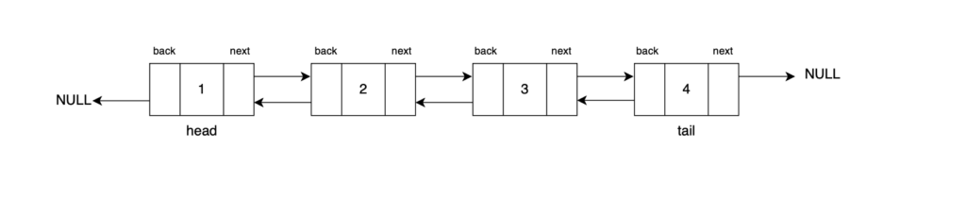
Step 2: Create a new node with its data as k and back pointer pointing to tail and next pointer pointing to null as the new tail will point to null.
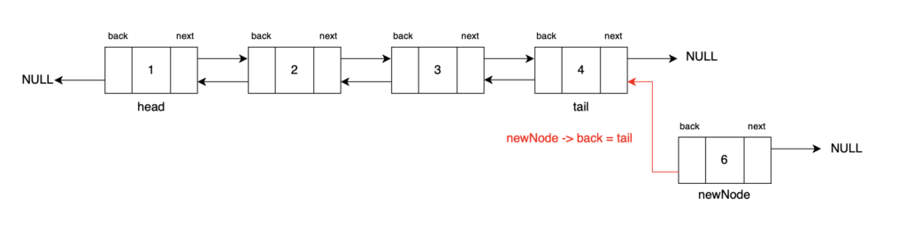
Step 3: Update the next pointer of the current tail node to point to the newly created node which will be our new tail post this. Then, return the head of the updated doubly linked list.
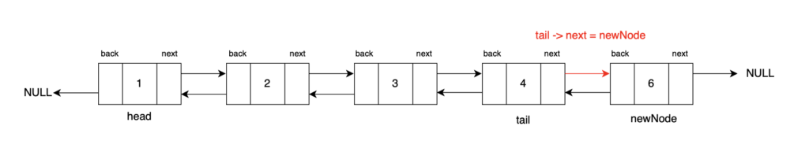

Code:
C++
#include <iostream>
#include <bits/stdc++.h>

using namespace std;

// Define a Node class for doubly linked list
class Node {
public:
// Data stored in the node
int data;
// Pointer to the next node in the list (forward direction)
Node* next;
// Pointer to the previous node in the list (backward direction)
Node* back;

// Constructor for a Node with both data, a reference to the next node, and a reference to the previous node
Node(int data1, Node* next1, Node* back1) {
data = data1;
next = next1;
back = back1;
}

// Constructor for a Node with data, and no references to the next and previous nodes (end of the list)
Node(int data1) {
data = data1;
next = nullptr;
back = nullptr;
}
};

// Function to convert an array to a doubly linked list
Node* convertArr2DLL(vector<int> arr) {
// Create the head node with the first element of the array
Node* head = new Node(arr[0]);
// Initialize 'prev' to the head node
Node* prev = head;

for (int i = 1; i < arr.size(); i++) {
// Create a new node with data from the array and set its 'back' pointer to the previous node
Node* temp = new Node(arr[i], nullptr, prev);
// Update the 'next' pointer of the previous node to point to the new node
prev->next = temp;
// Move 'prev' to the newly created node for the next iteration
prev = temp;
}
// Return the head of the doubly linked list
return head;
}

// Function to print the elements of the doubly linked list
void print(Node* head) {
while (head != nullptr) {
// Print the data in the tail node
cout << head->data << " ";
// Move to the next node
head = head->next;
}
}

// Function to insert a new node with value 'k' at the end of the doubly linked list
Node* insertAtTail(Node* head, int k) {
// Create a new node with data 'k'
Node* newNode = new Node(k);

// If the doubly linked list is empty, set 'head' to the new node
if (head == nullptr) {
return newNode;
}

// Traverse to the end of the doubly linked list
Node* tail = head;
while (tail->next != nullptr) {
tail = tail->next;
}

// Connect the new node to the last node in the list
tail->next = newNode;
newNode->back = tail;

return head;
}

int main() {
vector<int> arr = {12, 5, 8, 7, 4};
Node* head = convertArr2DLL(arr);

cout << "Doubly Linked List Initially: " << endl;
print(head);

cout << endl << "Doubly Linked List After Inserting at the tail with value 10: " << endl;
// Insert a node with value 10 at the end
head = insertAtTail(head, 10);
print(head);

return 0;
}
Output:
Doubly Linked List Initially:
12 5 8 7 4
Doubly Linked List After Inserting at the tail with value 10:
12 5 8 7 4 10
Time Complexity: O(N) The time complexity of this insertion operation is O(N) because we have to traverse the entire list to reach its tail. The complexity would be O(1) if we were given the tail node directly.
Space Complexity: O(1) The space complexity is also O(1) because we are not using any extra data structures to do the operations apart from creating a single new node.

